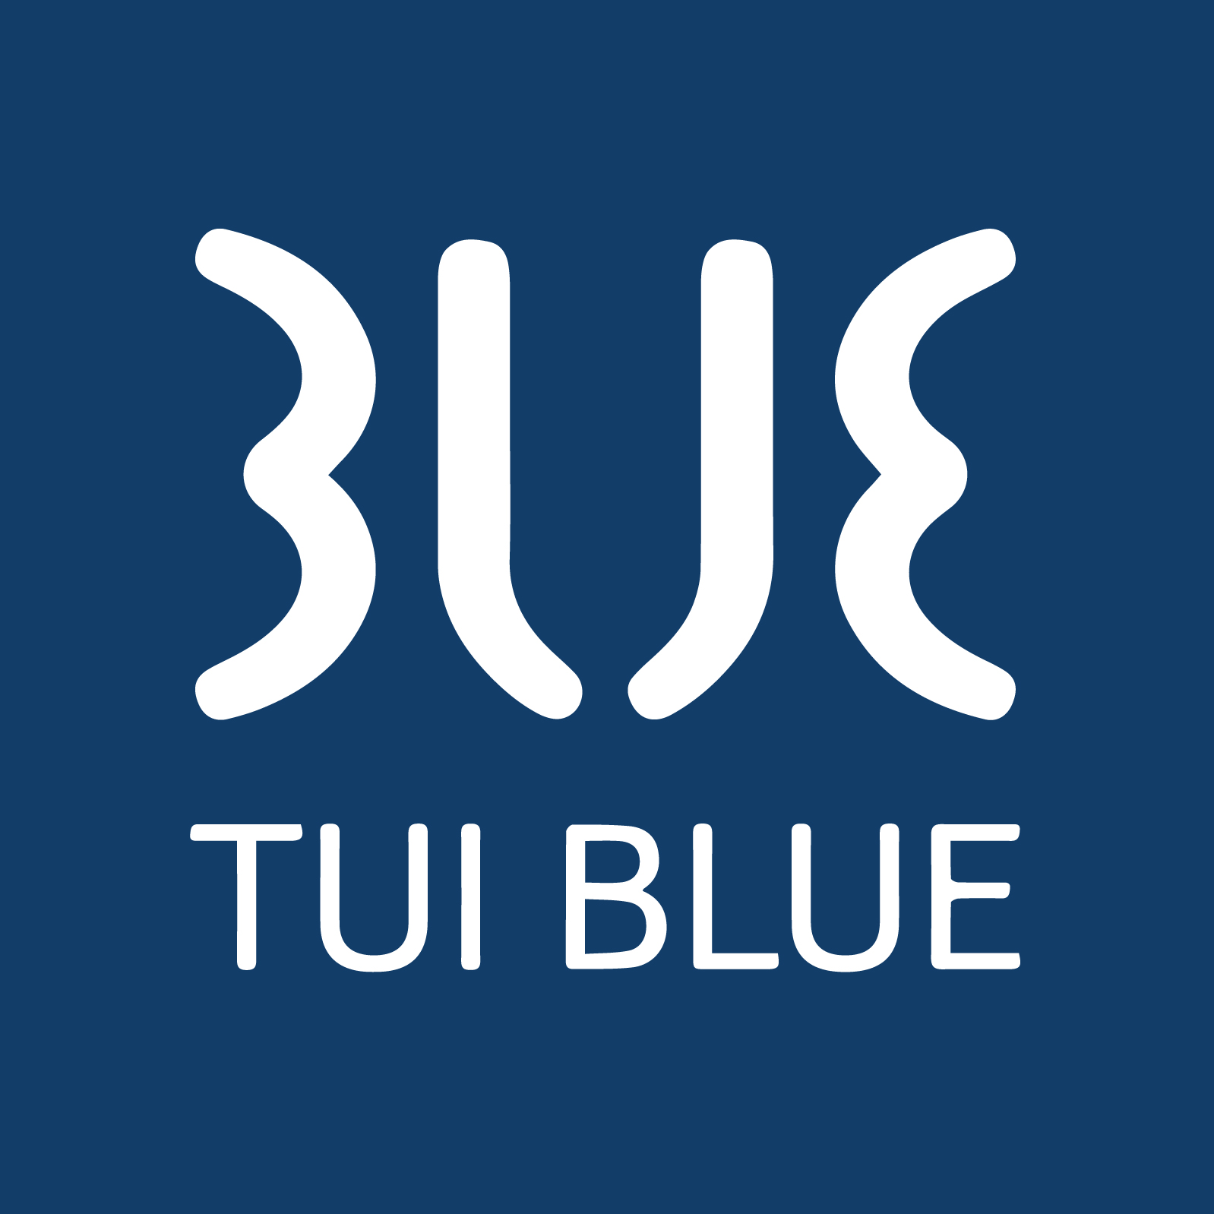
TUI BLUE The Passage – Commitment to People and the Planet
TUI BLUE The Passage is continually working to enhance the positive impact we have on the people and places that make our destination unique. We are committed to reducing our greenhouse gas emissions, protecting biodiversity, and supporting our local community through meaningful action.
In 2024, we set an ambitious target to reduce our greenhouse gas emissions from energy, water, and waste by 15% by the end of 2027.
We recognize that there is still much more to do. Throughout 2026, we will be introducing a range of new sustainability initiatives across our operations to help us reach our 2027 target. We kindly encourage our valued guests, team members, and visitors to join us in this journey by following the reminders displayed throughout the hotel about saving water and energy, and reducing waste wherever possible..
Looking ahead to 2026, our focus will be on supporting a local community enhancement project— TUI BLUE The Passage is committed to engaging guests and staff in sustainable practices through initiatives such as an on-site organic herb and vegetable garden, which supplies fresh ingredients for the hotel kitchen and offers guest tours and cooking classes where participants can learn about planting, harvesting, and preparing dishes.
At TUI BLUE The Passage, we are firmly committed to respecting and protecting human rights. We believe that everyone should be treated fairly, with dignity and respect, regardless of background, gender, or culture. To support this commitment, our staff receive regular training on diversity, inclusion, and the prevention of discrimination.
We also uphold the highest standards when it comes to safeguarding children and young people. Our team is trained to recognize and report any suspected cases of child exploitation or abuse. We have a zero-tolerance policy and immediately report all concerns to the local police authorities. We also encourage our guests, visitors, and community members to report any suspicions directly to the police by calling 911 or visiting the local police station.
Together, through awareness, action, and collaboration, TUI BLUE The Passage aims to make a lasting, positive impact on our environment, our community, and the lives of those around us.
Vicky Vorakamon
(Executive Assistant Manager)
Date: 12/10/2025

